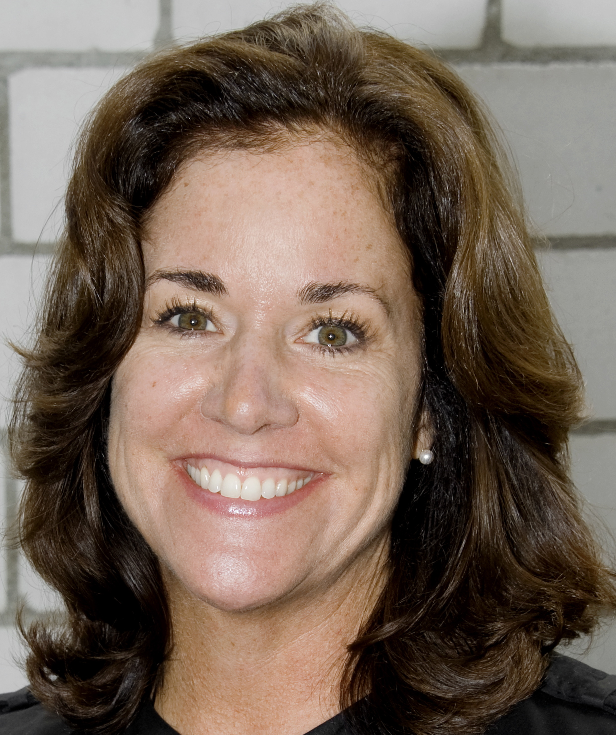

Mary-Jeanne « MJ »Cabanel MBA, CPCC

5 Chemin de Montelier • 1275 Chéserex, Switzerland • 41 79 705 9581 • mjcabanel@gmail.com • www.mjcabanel.com

PROFILE • Adept at building trust, creating alignment, and inspiring action on the part of teams and individuals for increased positivity and productivity in their lives.
• Proven workshop leader and facilitator on such topics as Inspirational Leadership, Influencing, Managing Change, and Work Life Balance
• Coach teams, leaders and individuals through organizational change processes, career transition and personal and professional transformation

EXPERIENCE

2007 - Present MJ Cabanel Coaching
Executive Coach, Trainer and facilitator
• Engage with individuals, teams and organizations throughout Europe, the Middle East and Africa for the purpose of creating fulfilment, partnership and productivity
- Partner with organizations such as Cargill, PwC, City of Oslo, The Global Fund to Fight AIDS, Tuberculosis and Malaria and Shire to facilitate workshops, strategy sessions, leadership training, team and individual coaching
- Senior Coach, Trainer, Consultant, Scouten Training Switzerland
- Front of the Room Leader, Member of the faculty, Coaches Training Institute (CTI)

2003 – 2007 E.I.M. S.A., Nyon, Switzerland
Business Development Officer
• Wrote proposals and responded to Requests for Proposals (RFPs) for leading financial institutions, pension plans, endowments and monetary authorities for the firm.
• Interfaced with prospective clients to determine their financial objectives in the Hedge Fund and Long-Only space in advance of creating proposed solutions
• Managed projects for launch of over USD 100 million in new custom-tailored, multi-manager fund of hedge fund portfolios.

2002 – 2003 INTERNATIONAL LABOUR ORGANIZATION (ILO), Geneva, Switzerland
Consultant to Management & Corporate Citizenship Programme, Employment Sector
• Published an executive training manual on social dialogue and worker relations for the Local Management Development Programmes (LMDP) carried out in Sri Lanka and Cambodia.
• Interfaced with local and field experts to offer practical, hands-on, active-learning training to garment manufacturers in the developing world.
• Drafted background sections on supply chain management in the footwear, apparel, and retail industries for a U.S. Department of State funded project entitled Business and Code of Conduct Implementation: How Firms Use Management Systems for Social Performance.

1999 -2002 Household Manager

1996 – 1999 THUNDERBIRD SCHOOL OF GLOBAL MANAGEMENT French Geneva Campus, Archamps, France
Business Development Europe
• Developed and directed the Thunderbird career management program in Europe; provided the vision for ongoing development of innovative career services for students, alumni, and employers.
• Developed internships and job placement opportunities for graduate management students by calling on international organizations and multinational corporations throughout Europe; succeeded in increasing jobs and internships ten-fold

1994 – 1996 HALIFAX CLINICAL RESEARCH INSTITUTE, Paris, France
Director International Marketing
• Created and implemented international marketing strategies for a U.S.-based clinical research organization that resulted in a five-fold increase in revenue and sale of the company at a profit.
• Responsible for new business development and maintaining existing relationships with division heads of large pharmaceutical and biopharmaceutical clients Novartis, Eli Lilly, Schering Plough, Merck

1992 – 1994 EMBASSY OF THE UNITED STATES OF AMERICA, Paris, France
Trade Event Recruiter/Exhibit Coordinator—U.S. Foreign and Commercial Service
• Recruited and coordinated the first U.S. pavilion at Eurosatory '94, an international land defense armaments exhibition attracting buyers from 90 nations worldwide and exhibitors from 20 countries.
• Designed and directed marketing campaigns to recruit more than 80 U.S. exhibitors.
• Conducted original market research studies on the French advertising market, the market for factoring services, and the environment for Franco/American joint

1990 – 1991 EXECUTIVE MEDIA CORPORATION, New York, New York
Account Executive
• Developed, marketed, and sold trade communication programs to international
manufacturers, including Clairol, Panasonic, and Singer for Housewares Executive.

1988 – 1990 PRUDENTIAL-BACHE SECURITIES, New York, New York
Financial Advisor
• Sold a wide range of financial securities to institutions and individuals; managed client portfolios

1986 – 1988 SMITH, BARNEY, HARRIS, UPHAM, New York, New York
Financial Advisor
• Marketed and structured stock, bond, and hybrid security portfolios for more than 250 individual, corporate and pension accounts; consistently ranked as one of the top ten sales trainees in USA

EDUCATION / TRAINING

2010 Center for Right Relationship (CRR), Certificate
•Organization and Relationship Systems Coaching

2009 Coaches Training Institute (CTI), Certified Professional Co-Active Coach (CPCC)
• Co-Active Coaching Fundamentals, Core Curriculum, Certification and Leadership Programs
- Selected as Front of the Room Leader

2007 - 2008 Coach University
• Core and Advanced Coaching Program

1993 MASTER OF BUSINESS ADMINISTRATION, MARKETING, CROSS CULTURAL COMMUNICATION
Thunderbird School of Global Management
• Editor in Chief of Das Tor, a weekly student newspaper

1986 BACHELOR OF ARTS, ART HISTORY, MINOR, ECONOMICS
Barnard College, Columbia University in the City of New York

ADDITIONAL • Personal: USA citizenship, French citizenship, Swiss Permit B, born 24/5/63, married, two children
• Languages: Native English speaker, fluent in French
- Memberships: International Coach Federation, Geneva Women in International Trade, Business and Professional Women International, American International Club
- Psychometrics : Profilor 360, Hogan, Firo B, MBTI, Mutirater 360, Highlands, Team Diagnostics

